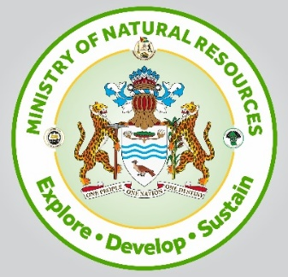

Apprenticeship Application Form
Interview Details
Student Name: Date: Time:
Address and Region: __________________________________________________________________
Date of Birth & Copy of Birth Certificate
D/M/Y: _____________________________
Area of Interest: ____________________________ Applicant Phone Number: __________________
School attended or
Attending __________________________________________________________________
Skills Acquired
Educational
Achievements _________________________________________________________________

___________________________________________________________________

____________________________________________________________________

____________________________________________________________________

300 words paragraph on Natural Resources, (Forestry & Mining / Oil & Gas)
Ministry of Natural Resources Permission Slip

Please return this permission slip by
I _________________ give permission for my child __________________________ to participate in MNR Apprenticeship Training program and Educational Field Trips from

Special instructions for child:
Dietary Restrictions:

Allergies/Ailments:

S

Emergency Contact:
Name: ________________________________________
Telephone Number/S: _____________________________________________
Email: _____________________________________________________

S

In Case of an emergency, I give permission for my child to receive medical treatment.

Parents or guardians are responsible for their child’s vaccination against communicable diseases or other.

Relation to applicant:

Signature:

Date:

* To be returned with application form

